Opening Minds, Opening doors

Colmers School and Sixth Form College
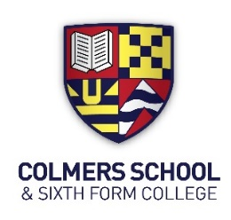

Key Stage 4 Maths

Year 11
Higher Tier
Year 11 Autumn Exam Preparation

Mock Exam Preparation

Paper 1 – Wednesday 27th November
Paper 2 – Monday 2nd December

NAME:
GROUP:
TEACHER:
Achieving Excellence, Belonging Together, Challenging Mindsets

Colmers School and Sixth Form College
Year 11 Maths Revision Booklet
Assessment Cycle Two



You have two mock exam papers during the mock exam period.
This booklet will help you revise and prepare thoroughly for your assessment.
- This revision booklet is compulsory homework and all tasks must be completed
- The first part of the booklet requires you to RAG rate the skills that you will be required to use in your assessment (see instructions on that page)
- If you do get stuck, watch the video clips or ask your teacher for help.
- Try your absolute best!

Your homework tasks consist of:
- Logging on to MathsWatch
- Completing an assignment
- Record your score and reflect on what you found easy and what you find difficult.
- Complete the revision checklist on page 3 and page 4
- Come up with a plan of action for what to do about your areas of development.

Log on details:
You will be expected to use https://vle.mathswatch.co.uk/vle/ to revise the topics listed in the revision booklet.
Your log in details will be:

Username:
Usual school login followed by @colmers
Password:
colmers
Colmers School and Sixth Form College
Year 11 Maths Revision Booklet
Assessment Cycle Two

Revision Checklist

Paper 1 Non-Calc Topics |  | Mathswatch task complete | Percentage achieved | Confidence | Extra revision completed
1 | Solving inequalities
2 | Product of prime factors
3 | Fractions, Percentages & Ratio
4 | Standard form
5 | Angles in polygons
6 | Quadratic graphs
7 | Density / Mass / Volume
8 | Estimate of the mean
9 | Surface area
10 | Cumulative frequency
11 | Ratio / Fraction
12 | Recurring decimals
13 | Sectors / Pythagoras
14 | Gradient at a point
15 | Vectors
16 | Independent events
17 | Direct & inverse proportion
18 | Fractional and negative indices
19 | Algebraiic fractions
20 | Tangent to a circle
21 | Sectors / Area of a triangle

Paper 2 Calculator Topics |  | Mathswatch task complete | Percentage achieved | Confidence | Extra revision completed
1 | Index Laws
2 | Simplifying expressions
3 | Factorising expressions
4 | Translations
5 | Error intervals
6 | Area
7 | Coordinates & Ratio
8 | Depreciation
9 | Exchange Rates
10 | Use of calculator
11 | Pressure / Force / Area
12 | Box Plots
13 | Inverse Proportion
14 | y = mx + c
15 | Enlargements
16 | Capture - recapture
17 | Ratio
18 | Venn diagrams
19 | Cones and spheres
20 | Sine and Cosine Rule
21 | Functions
22 | Circle Theorems
23 | Transforming functions
24 | Quadratic inequalities

Colmers School and Sixth Form College
Year 11 Maths Revision Booklet
Assessment Cycle Two
Complete the table below regarding your reflections on your revision work.
The key areas that I have improved my knowledge and understanding are in the following:

The topics I have improved in the most are:
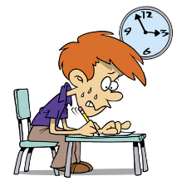

The main type of revision method I used is:
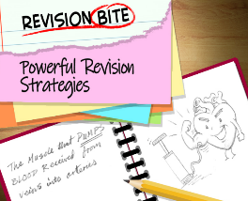

Further revision that I need to complete is:
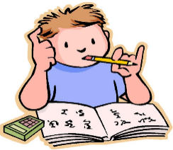

Teacher’s reflection:
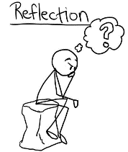

Signed:

