
YEAR 11
Daily plans

revision

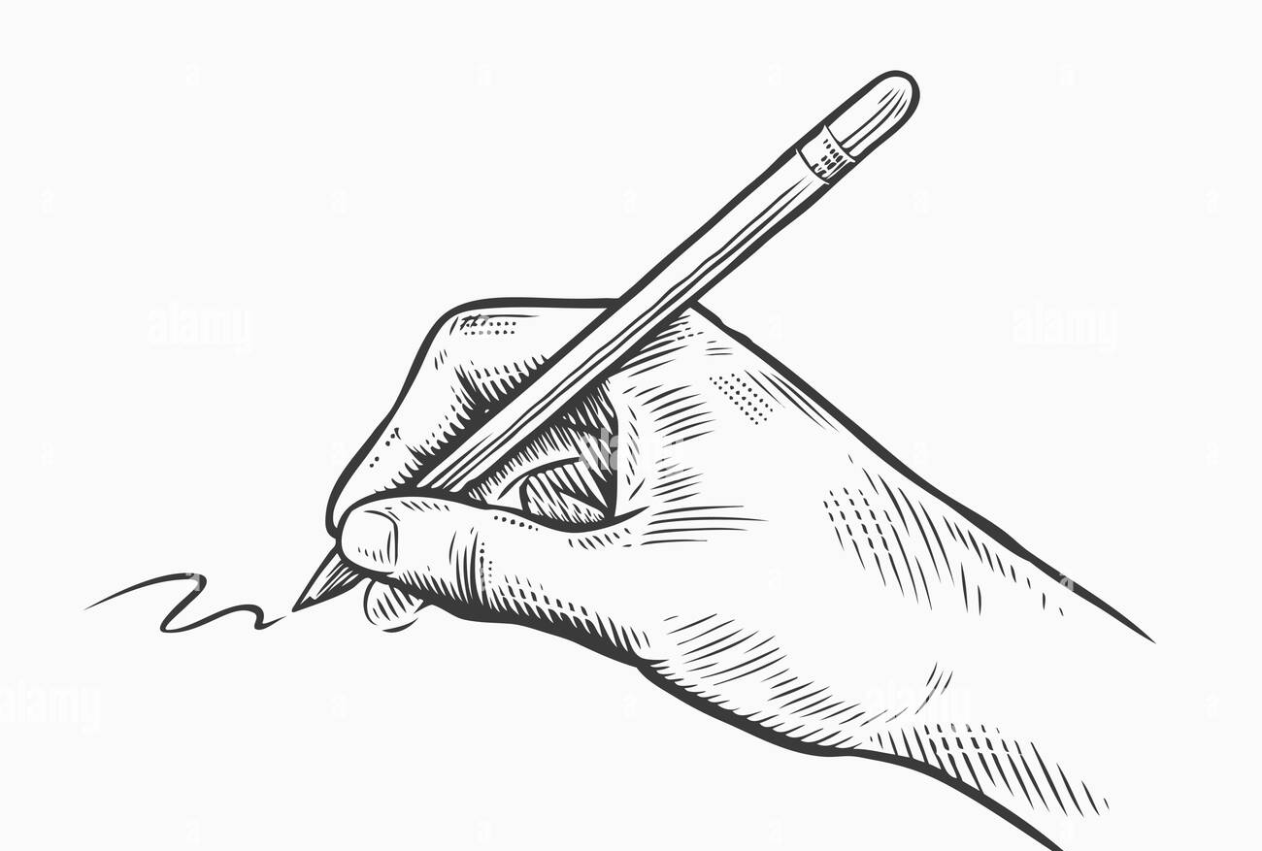

Name:
Class:
Teacher:

EXAMPLE PLANS
Minimum ingredients
Optional extras
Macbeth, Jekyll & Hyde, An Inspector Calls

Poetry ingredients
Power & Conflict

CONTENTS PAGE
Date and Focus | Page | Tick
EXAMPLE PLAN PAGE | 2 | N/A
Contents pages | 3-4
Monday 20th January: Macbeth | 5
Tuesday 21st January: Jekyll & Hyde | 6
Wednesday 22nd January: An Inspector Calls | 7
Thursday 23rd January: Power and Conflict Poetry | 8
Optional extras: Unseen poem and Language Paper 2 Question 4 | 9
Monday 27th January: Macbeth | 10
Tuesday 28th January: Jekyll & Hyde | 11
Wednesday 29th January: An Inspector Calls | 12
Thursday 30th January: Power and Conflict Poetry | 13
Optional extra: Unseen poem and Language Paper 2 Question 3 and Question 5 | 14
Monday 3rd February: Macbeth | 15
Tuesday 4th February: Jekyll & Hyde | 16
Wednesday 5th February: An Inspector Calls | 17
Thursday 6th February: Power and Conflict Poetry | 18
Optional extra: Unseen poem and Language Paper 2 Question 4 | 19
Monday 10th February: Macbeth | 20
Tuesday 11th February: Jekyll & Hyde | 21
Wednesday 12th February: An Inspector Calls | 22
Thursday 13th February: Power and Conflict Poetry | 23
Optional extra: Unseen poem and Language Paper 2 Question 3 | 24
Monday 10th March: Macbeth | 25
Tuesday 11th March: Jekyll & Hyde | 26
Wednesday 12th March: An Inspector Calls | 27
Thursday 13th March: Power and Conflict Poetry | 28
Optional extra: Unseen poem and Language Paper 1 Question 5 | 29
Monday 17th March: Macbeth | 30
Tuesday 18th March: Jekyll & Hyde | 31
Wednesday 19th March: An Inspector Calls | 32
Thursday 20th March: Power and Conflict Poetry | 33
Optional extra: Language P1Q1, P1Q3, P2Q3 and P2Q5 | 34
Monday 24th March: Macbeth | 35
Tuesday 25th March: Jekyll & Hyde | 36
Wednesday 26th March: An Inspector Calls | 37
Thursday 27th March: Power and Conflict Poetry | 38
Optional extra: Language Paper 1 Question 2 and Language Paper 2 Question 4 | 39
Monday 31st March: Macbeth | 40
Tuesday 1st April: Jekyll & Hyde | 41
Wednesday 2nd April: An Inspector Calls | 42
Thursday 3rd April: Power and Conflict Poetry | 43
Optional extra: Language Paper 1 Q3 and Q4, Language Paper 2 Q5 | 44
Monday 7th April: Macbeth | 45
Tuesday 8th April: Jekyll & Hyde | 46
Wednesday 9th April: An Inspector Calls | 47
Thursday 10th April: Power and Conflict Poetry | 48
Optional extra: Unseen poem and Language Paper 1 Question 5 | 49
Monday 28th April: Macbeth | 50
Tuesday 29th April: Jekyll & Hyde | 51
Wednesday 30th April: An Inspector Calls | 52
Thursday 1st May: Power and Conflict Poetry | 53
Optional extra: Language Paper 1 Q2, Q3, Q4 and Q5. | 54
Monday 5th May: Macbeth | 55
Tuesday 6th May: Jekyll & Hyde | 56
Wednesday 7th May: An Inspector Calls | 57
Thursday 8th May: Power and Conflict Poetry | 58
Optional writing space | 59-64 | N/A

Monday 20th January | Macbeth
Read the following extract from act 1 scene 7. Macbeth is unsure about the plan to kill Duncan.

MACBETH
If it were done when 'tis done, then 'twere well
It were done quickly: if the assassination
Could trammel up the consequence, and catch
With his surcease success; that but this blow
Might be the be-all and the end-all here,
But here, upon this bank and shoal of time,
We'ld jump the life to come. But in these cases
We still have judgment here; that we but teach
Bloody instructions, which, being taught, return
To plague the inventor: this even-handed justice
Commends the ingredients of our poison'd chalice
To our own lips. He's here in double trust;
First, as I am his kinsman and his subject,
Strong both against the deed; then, as his host,
Who should against his murderer shut the door,
Not bear the knife myself. Besides, this Duncan
Hath borne his faculties so meek, hath been
So clear in his great office, that his virtues
Will plead like angels, trumpet-tongued, against
The deep damnation of his taking-off;
And pity, like a naked new-born babe,
Striding the blast, or heaven's cherubim, horsed
Upon the sightless couriers of the air,
Shall blow the horrid deed in every eye,
That tears shall drown the wind. I have no spur
To prick the sides of my intent, but only
Vaulting ambition, which o'erleaps itself
And falls on the other.

Starting with this extract, how does Shakespeare present ideas about ambition in Macbeth?

Tuesday 21st January | Jekyll & Hyde
Read the following extract from Chapter 1 and then answer the question that follows.
In this extract Mr Enfield tells Mr Utterson about his meeting with Mr Hyde.

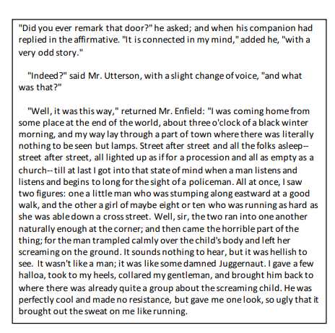
Starting with this extract, how does Stevenson present Mr Hyde as a frightening outsider??
Wednesday 22nd January |  | An Inspector Calls
You should choose one question to plan an answer.

- Explore how Priestley presents Mrs Birling as a typical upper class woman of the time.

or

- Explore how Priestley presents ideas about taking responsibility for your actions in An Inspector Calls.

Thursday 23rd January | Power and Conflict Poetry
Compare how poets present war in ‘Charge of the Light Brigade’ and one other poem.
Flashed all their sabres bare,
Flashed as they turned in air
Sabring the gunners there,
Charging an army, while
All the world wondered.
Plunged in the battery-smoke
Right through the line they broke;
Cossack and Russian
Reeled from the sabre stroke
Shattered and sundered.
Then they rode back, but not
Not the six hundred.

Cannon to right of them,
Cannon to left of them,
Cannon behind them
Volleyed and thundered;
Stormed at with shot and shell,
While horse and hero fell.
They that had fought so well
Came through the jaws of Death,
Back from the mouth of hell,
All that was left of them,
Left of six hundred.

When can their glory fade?
O the wild charge they made!
All the world wondered.
Honour the charge they made!
Honour the Light Brigade,
Noble six hundred!

Charge of the Light Brigade – Alfred Lord Tennyson

Half a league, half a league,
Half a league onward,
All in the valley of Death
Rode the six hundred.
“Forward, the Light Brigade!
Charge for the guns!” he said.
Into the valley of Death
Rode the six hundred.

“Forward, the Light Brigade!”
Was there a man dismayed?
Not though the soldier knew
Someone had blundered.
Theirs not to make reply,
Theirs not to reason why,
Theirs but to do and die.
Into the valley of Death
Rode the six hundred.

Cannon to right of them,
Cannon to left of them,
Cannon in front of them
Volleyed and thundered;
Stormed at with shot and shell,
Boldly they rode and well,
Into the jaws of Death,
Into the mouth of hell
Rode the six hundred.

Optional extras | Unseen poetry and language paper 2
UNSEEN POETRY

Blessing
The skin cracks like a pod.
There never is enough water.

Imagine the drip of it,
the small splash, echo
in a tin mug,
the voice of a kindly god.

Sometimes, the sudden rush
of fortune. The municipal pipe bursts,
silver crashes to the ground
and the flow has found
a roar of tongues. From the huts,
a congregation : every man woman
child for streets around
butts in, with pots,
brass, copper, aluminium,
plastic buckets,
frantic hands,

and naked children
screaming in the liquid sun,
their highlights polished to perfection,
flashing light,
as the blessing sings
over their small bones.

- Imtiaz Dharker

How does the poet present the speaker’s attitude towards water?
LANGUAGE PAPER 2

Q4: Compare the writers’ viewpoints on the fog of London.

SOURCE A – 1853 - The winter-fogs of London are, indeed, awful. They surpass all imagining; he who never saw them, can form no idea of what they are. He who knows how powerfully they affect the minds and tempers of men, can understand the prevalence of that national disease—the spleen. In a fog, the air is hardly fit for breathing; it is grey-yellow, of a deep orange, and even black at the same time, it is moist, thick, full of bad smells, and choking. The fog appears, now and then, slowly, like a melo­dramatic ghost, and sometimes it sweeps over the town as the simoom over the desert. At times, it is spread with equal density over the whole of that ocean of houses on other occasions, it meets with some invisible obstacle, and rolls itself into intensely dense masses, from which the passengers come forth in the manner of the student who came out of the cloud to astonish Dr. Faust. It is hardly necessary to mention, that the fog is worst in those parts of the town which are near the Thames. (Max Schlesinger)

SOURCE B – 1959 - Fog stretched last night from the Home Counties westwards into Devon and South Wales and northwards through the Midlands and East Anglia up to Yorkshire. It is expected to persist to-day. The Department of Scientific and Industrial Research said that a reading of the filter at the Greenwich laboratory of its atmosphere pollution division showed that the average concentration of smoke was 2.48 milligrams a cubic metre. At midday the average concentration during the previous 24 hours was 1.3. The Automobile Association described conditions in London and the Home Counties, where the fog had persisted for twenty-four hours, as “very grim.” Visibility in South-east London varied between nil and ten yards. Not one scheduled incoming or outgoing service was able to operate at London Airport during the day. Visibility was down to twenty yards there. About 44 outgoing and 30 incoming Continental flights bad been cancelled by evening.
Monday 27th January | Macbeth
Read the following extract from act 2 scene 1. Macbeth is preparing to kill King Duncan.

MACBETH
Go bid thy mistress, when my drink is ready,
She strike upon the bell. Get thee to bed.
Exit Servant
Is this a dagger which I see before me,
The handle toward my hand? Come, let me clutch thee.
I have thee not, and yet I see thee still.
Art thou not, fatal vision, sensible
To feeling as to sight? or art thou but
A dagger of the mind, a false creation,
Proceeding from the heat-oppressed brain?
I see thee yet, in form as palpable
As this which now I draw.
Thou marshall'st me the way that I was going;
And such an instrument I was to use.
Mine eyes are made the fools o' the other senses,
Or else worth all the rest; I see thee still,
And on thy blade and dudgeon gouts of blood,
Which was not so before. There's no such thing:
It is the bloody business which informs
Thus to mine eyes.

Starting with this extract, how does Shakespeare present Macbeth as a strong character in Macbeth?
Tuesday 28th January | Jekyll & Hyde
Read the following extract from chapter 2. In this extract Mr Utterson looks at Dr Jekyll’s will, having just heard about the violence of Mr Hyde.
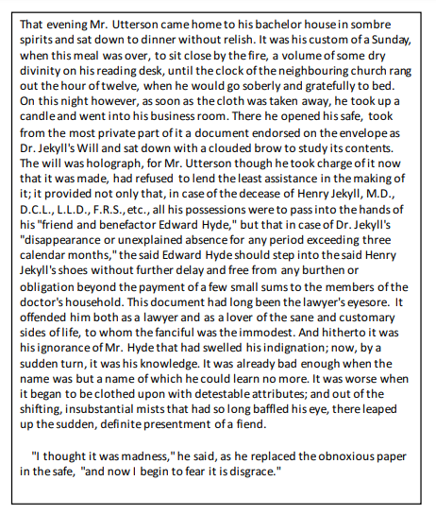
Starting with this extract, how does Stevenson present Mr Utterson as a rational and reliable narrator?
Wednesday 29th January |  | An Inspector Calls
You should choose one question to plan an answer.

- Explore how Priestley presents Mr Birling as a selfish individual in An Inspector Calls.

or

- Explore how Priestley presents ideas about gender inequality in An Inspector Calls.

Thursday 30th January | Power and Conflict Poetry
Compare how poets present the power of nature in ‘Storm on the Island’ and one other poem.

Storm on the Island – Seamus Heaney

We are prepared: we build our houses squat,
Sink walls in rock and roof them with good slate.
This wizened earth has never troubled us
With hay, so, as you see, there are no stacks
Or stooks that can be lost. Nor are there trees
Which might prove company when it blows full
Blast: you know what i mean — leaves and branches
Can raise a tragic chorus in a gale
So that you listen to the thing you fear
Forgetting that it pummels your house too.
But there are no trees, no natural shelter.
You might think that the sea is company,
Exploding comfortably down on the cliffs,
But no: when it begins, the flung spray hits
The very windows, spits like a tame cat
Turned savage. We just sit tight while wind dives
And strafes invisibly. Space is a salvo,
We are bombarded by the empty air.
Strange, it is a huge nothing that we fear.

Optional extras | Unseen poetry and language paper 2
UNSEEN POETRY

Quickdraw

I wear the two, the mobile and the landline phones,
like guns, slung from the pockets on my hips. I’m all
alone. You ring, quickdraw, your voice a pellet
in my ear, and hear me groan.

You’ve wounded me.
Next time, you speak after the tone. I twirl the phone,
then squeeze the trigger of my tonge, wide of the mark.
You choose your spot, then blast me

through the heart.
And this is love, high noon, calamity, hard liqour
in the old Last Chance saloon. I show the mobile
to the sheriff; in my boot, another one’s

concealed. You text them both at once. I reel.
Down on my knees, I fumble for the phone,
read the silver bullets of your kiss. Take this …
and this … and this … and this … and this …
- Carol Ann Duffy

How does the poet present the speaker’s attitude towards her relationship and mobile phones?

LANGUAGE PAPER 2
Q3: How does the writer use language to convey their feelings about mobile phones.

SOURCE A – 2024 – Will Klempner ‘Hunched over my smartphone while my family slept, I knew I had to break my addiction. But how?’
I can’t pinpoint the exact moment I became addicted to my phone. It happens without you noticing, like a frog slowly boiling in a pot. I always told myself my excessive screen time wasn’t a big deal, that my life was better with my phone in it. I made every excuse in the book: I was learning new things, keeping my finger on the pulse, being an efficient employee and staying up to date with the people I love.
But in reality, none of that was true. My phone was such a powerful drug precisely because it gave me the illusion that it held infinite possibilities. But my experience of time and culture had slowly become flattened into two-dimensional memes and philosophical quotes, and I would bypass anything real – messages unanswered, calls unreturned – in favour of getting the next hit of dopamine. I found myself numb, disconnected from the world around me and unable to concentrate on anything for longer than a few minutes.
At the peak of my addiction, I would sit in the bathroom for hours after my wife had gone to bed, mindlessly scrolling, until I’d look up and realise another evening had slipped away, and all I had to show for it was a stiff neck and a sore thumb. By this point, the screen had become an escape from feelings of self-hate, and I knew something had to change. So I turned to the only resource I thought could help me.
There’s a certain irony in thinking that the solution to a problem with phone addiction can be found on your phone. But that’s the insidiousness of the whole thing. I set time limits, sought out podcasts and resources on how to claim back my attention. I had my wife apply a password to any app that wasn’t deemed “essential”. But in every instance, I found a way round it. And without immediate access to social media, I found myself scrolling through anything I could get my thumb on: photos, notes – even the weather app.Continental flights bad been cancelled by evening.

Q5 “Mobile phones are addictive, costly, and ultimately dangerous. We should prevent children from having access to mobile phones” – Write a speech for your teachers about mobile phones and teenagers.
Monday 3rd February | Macbeth
Read the following extract from act 3 scene 4. Macbeth is at the banquet and sees Banquo’s ghost.

MACBETH
Thou canst not say I did it: never shake
Thy gory locks at me.
ROSS
Gentlemen, rise: his highness is not well.
LADY MACBETH
Sit, worthy friends: my lord is often thus,
And hath been from his youth: pray you, keep seat;
The fit is momentary; upon a thought
He will again be well: if much you note him,
You shall offend him and extend his passion:
Feed, and regard him not. Are you a man?
MACBETH
Ay, and a bold one, that dare look on that
Which might appal the devil.
LADY MACBETH
O proper stuff!
This is the very painting of your fear:
This is the air-drawn dagger which, you said,
Led you to Duncan. O, these flaws and starts,
Impostors to true fear, would well become
A woman's story at a winter's fire,
Authorized by her grandam. Shame itself!
Why do you make such faces? When all's done,
You look but on a stool.

Starting with this extract, how does Shakespeare present ideas about gender in Macbeth?
Tuesday 4th February | Jekyll & Hyde
Read the following extract from chapter 4. In this extract a maid-servant tells the story of Mr Hyde’s violent attack on Sir Danvers Carew

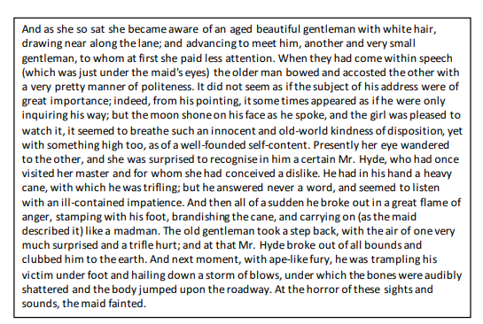
Starting with this extract, write about how Stevenson presents the use of violence in the novel?
Wednesday 5th February |  | An Inspector Calls
You should choose one question to plan an answer.

- Explore how Priestley presents Sheila as a character who changes throughout the play.

or

- Explore how Priestley presents ideas about the impact of guilt in An Inspector Calls.

Thursday 6th February | Power and Conflict Poetry
Compare how poets present the power of a place in ‘The Emigree’ and one other poem.

The Emigree – Carol Rumens
There once was a country... I left it as a child
but my memory of it is sunlight-clear
for it seems I never saw it in that November
which, I am told, comes to the mildest city.
The worst news I receive of it cannot break
my original view, the bright, filled paperweight.
It may be at war, it may be sick with tyrants,
but I am branded by an impression of sunlight.

The white streets of that city, the graceful slopes
glow even clearer as time rolls its tanks
and the frontiers rise between us, close like waves.
That child’s vocabulary I carried here
like a hollow doll, opens and spills a grammar.
Soon I shall have every coloured molecule of it.
It may by now be a lie, banned by the state
but I can’t get it off my tongue. It tastes of sunlight.

I have no passport, there’s no way back at all
but my city comes to me in its own white plane.
It lies down in front of me, docile as paper;
I comb its hair and love its shining eyes.
My city takes me dancing through the city
of walls. They accuse me of absence, they circle me.
They accuse me of being dark in their free city.
My city hides behind me. They mutter death,
and my shadow falls as evidence of sunlight.
Optional extras | Unseen poetry and language paper 2
UNSEEN POETRY

Make the Ordinary Come Alive

Do not ask your children
to strive for extraordinary lives.
Such striving may seem admirable,
but it is a way of foolishness.
Help them instead to find the wonder
and the marvel of an ordinary life.
Show them the joy of tasting
tomatoes, apples, and pears.
Show them how to cry
when pets and people die.
Show them the infinite pleasure
in the touch of a hand.
And make the ordinary come alive for them.
The extraordinary will take care of itself.

- William Martin

How does the poet present the speaker’s attitude towards life and being a parent?
LANGUAGE PAPER 2

Q4: Compare the writers’ viewpoints on Covent Garden Market.

SOURCE A – 1872 - Covent Garden Market, however, is the most famous place of barter in England:, it has been said, by people who forget the historical Halle of Paris, in the world. A stroll through it, and around it, when the market is opening on a summer morning, between four and five, affords the visitor a score of points of interest, and some matter for reflection. As at Billingsgate and in the Borough, the surrounding streets are choked with waggons and barrows. The street vendors are of all kinds, and of the poorest of each kind, if the coffee stall keepers be excepted. The porters amble in all directions under loads of prodigious bulk. Lifted upon stalwart shoulders, towers of baskets travel about. From the tails of carts producers or "higglers" are selling off mountainous loads of cabbages. The air is fragrant with fruit to the north, and redolent of stale vegetables to the south. The piazzas, of pleasant memory and where a few noteworthy social clubs still linger, are alive with stalls, scattered sieves, market-gardeners, greengrocers, poor women and children in troops (these are everywhere on our way), and hawkers old and young eagerly on the look out for an advantageous transaction with a higgler, or direct from the producer. Within the market enclosure the stacks of vegetables, and the piles of fruit baskets and boxes, are of startling extent.

SOURCE B – 2023 - Ah, Covent Garden. As someone with expensive taste, it’s one of my favourite places to go in London - regardless of whether I’m popping into a cosy pub or picking up some street food.
However, as a self-confessed, reckless shopaholic I am determined to stop spending so much this year. So in a bid to ignore the siren calls of store windows, my new mantra is shopping at markets. Covent Garden Market is a magnet for tourists. Having never properly been before, I decided to head along one Wednesday afternoon to see if I could pick up something for less than a fiver. My first visit was to Apple Market, which was rather easy to spot with its central location within the historic piazza. As soon as I stepped up to the first trader I knew that this challenge was a risky investment. The little artisan stalls were all brimming with a wide variety of gifts - from handmade jewellery to prints of the City of London. However, one thing remained the same. Cost. Everything was spoiled by the hefty prices. For a tiny bracelet or ring you had to fork out over £20 and if you wanted the most basic keyring - that was a whopping £8. Also, there was hardly any variation. It was just a repeat of the predictable: jewellery, London merchandise, bars of soap and hand-made prints.

Monday 10th February | Macbeth
Read the following extract from act 4 scene 1. Macbeth has returned to the witches as King of Scotland.

Second Witch
By the pricking of my thumbs,
Something wicked this way comes.
Open, locks,
Whoever knocks!
Enter MACBETH
MACBETH
How now, you secret, black, and midnight hags!
What is't you do?
ALL
A deed without a name.
MACBETH
I conjure you, by that which you profess,
Howe'er you come to know it, answer me:
Though you untie the winds and let them fight
Against the churches; though the yesty waves
Confound and swallow navigation up;
Though bladed corn be lodged and trees blown down;
Though castles topple on their warders' heads;
Though palaces and pyramids do slope
Their heads to their foundations; though the treasure
Of nature's germens tumble all together,
Even till destruction sicken; answer me
To what I ask you.

Starting with this extract, how does Shakespeare present ideas about the supernatural in Macbeth?
Tuesday 11th February | Jekyll & Hyde
Read the following extract from chapter 8. In this extract Mr Utterson travels across London to find out what is wrong with Dr Jekyll.
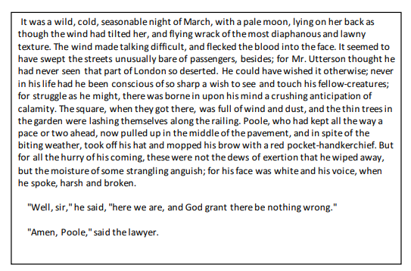

Starting with this extract, how does Stevenson use the setting to create tension in the novel??
Wednesday 12th February |  | An Inspector Calls
You should choose one question to plan an answer.

- Explore how Priestley presents Eric as a character who learns lessons in An Inspector Calls.

or

- Explore how Priestley presents the older generation in An Inspector Calls.

Thursday 13th February | Power and Conflict Poetry
Compare how poets present the power of nature in ‘Storm on the Island’ and one other poem.

War Photographer – Carol Ann Duffy
In his dark room he is finally alone
with spools of suffering set out in ordered rows.
The only light is red and softly glows,
as though this were a church and he
a priest preparing to intone a Mass.
Belfast. Beirut. Phnom Penh. All flesh is grass.

He has a job to do. Solutions slop in trays
beneath his hands, which did not tremble then
though seem to now. Rural England. Home again
to ordinary pain which simple weather can dispel,
to fields which don’t explode beneath the feet
of running children in a nightmare heat.

Something is happening. A stranger’s features
faintly start to twist before his eyes,
a half-formed ghost. He remembers the cries
of this man’s wife, how he sought approval
without words to do what someone must
and how the blood stained into foreign dust.

A hundred agonies in black and white
from which his editor will pick out five or six
for Sunday’s supplement. The reader’s eyeballs prick
with tears between the bath and pre-lunch beers.
From the aeroplane he stares impassively at where
he earns his living and they do not care.
Optional extras | Unseen poetry and language paper 2
UNSEEN POETRY

Grief

Trying to remember you
is like carrying water
in my hands a long distance
across sand. Somewhere people are waiting.
They have drunk nothing for days.

Your name was the food I lived on;
now my mouth is full of dirt and ash.
To say your name was to be surrounded
by feathers and silk; now, reaching out,
I touch glass and barbed wire.
Your name was the thread connecting my life;
now I am fragments on a tailor's floor.

I was dancing when I
learned of your death; may
my feet be severed from my body

- Stephen Dobyns

How does the poet present the speaker’s attitude towards loss and losing another person?
LANGUAGE PAPER 2
Q3: How does the writer use language to convey their feelings about mobile phones.

SOURCE A – 2025 – Chloe Hamilton ‘Fast fashion is an addiction. Secondhand shopping mania may be just as bad’
Guess how much this was,” I say to my partner mischievously, revealing with relish the latest toy I’ve found for our youngest son. It’s wooden, Montessori in style (apparently a ball dropping through a hole teaches him object permanence), and retails at about £20 new. “A quid,” my partner proffers, wearily: he is savvy to this game by now. This time, though, I can go one better. “Free!” I screech with glee. “Free! Can you believe that? Someone was giving it away on that secondhand WhatApp group.” I’m giddy with my find, drunk on the size of the bargain, but, as I add the new (to me) toy to the teetering pile of others – dolls, a tunnel, toy cars, a lunchbox – I can feel something – guilt, I think – gnawing away at me. Am I a secondhand overconsumer?
I’ve always been a champion of secondhand shopping. I was plundering charity shops before it was cool and, in a tale that has become family folklore, once found a standard lamp in a branch of the British Heart Foundation and carried it home on the bus. In fairness, that lamp has moved house with me seven times and still stands, resplendent, in my living room. But I fear too many of my other secondhand purchases have been flash-in-the-pan dopamine hits. These purchases gather dust in our bedroom, the study, my son’s toy box. Clothes I’ve bought from charity shops, heady with the exhilaration of them being “only £5”, lie crumpled and forgotten in the depths of my wardrobe before, months later, being dragged out and sold on Vinted for a couple of quid. And still I buy more, ensnared in the grip of what I’ve started to believe is something akin to an addiction.
Like other addicts, I convince myself my bargain-hunting habit isn’t, actually, unhealthy – something that’s surprisingly easy to do these days. Everyone, everywhere, is extolling to me the virtues of secondhand shopping: for the environment, for my wallet, for charities in need of funds. Apps (I have them all: Vinted, Depop, eBay) fuel my habit. I scroll through cheap clothes and toys at night and, at times, find myself unable to sleep because of the buzzy excitement of a purchase. I track my item’s delivery, logging on to the apps regularly to watch the dress, skirt or bag travel across the country. Of course, this is the most exciting bit. Inevitably, when whatever I’ve bought arrives – dropped off by a now familiar delivery driver – the anticipation evaporates.

Monday 10th March | Macbeth
Read the following extract from act 5 scene 8. Macbeth faces Macduff during the attack on Scotland.

MACDUFF
Tell thee, Macduff was from his mother's womb
Untimely ripp'd.
MACBETH
Accursed be that tongue that tells me so,
For it hath cow'd my better part of man!
And be these juggling fiends no more believed,
That palter with us in a double sense;
That keep the word of promise to our ear,
And break it to our hope. I'll not fight with thee.
MACDUFF
Then yield thee, coward,
And live to be the show and gaze o' the time:
We'll have thee, as our rarer monsters are,
Painted on a pole, and underwrit,
'Here may you see the tyrant.'
MACBETH
I will not yield,
To kiss the ground before young Malcolm's feet,
And to be baited with the rabble's curse.
Though Birnam wood be come to Dunsinane,
And thou opposed, being of no woman born,
Yet I will try the last. Before my body
I throw my warlike shield. Lay on, Macduff,
And damn'd be him that first cries, 'Hold, enough!'

Starting with this extract, how does Shakespeare present Macbeth as a character who changes in Macbeth?
Tuesday 11th March | Jekyll & Hyde
Read the following extract from chapter 8. In this extract Mr Utterson has arrived at Dr Jekyll’s house to work out what has happened to him. The butler, Poole, takes Mr Utterson to Dr Jekyll’s laboratory.
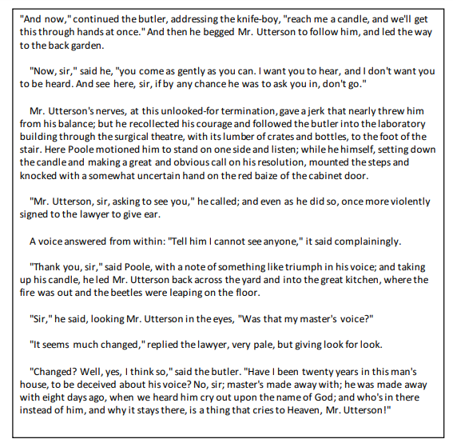
Starting with this extract, write about how Stevenson creates a sense of fear and horror in the novel?

Wednesday 12th March |  | An Inspector Calls
You should choose one question to plan an answer.

- Explore how Priestley presents Gerald as a character who resists change in An Inspector Calls.

or

- Explore how Priestley presents ideas how society needs to change in An Inspector Calls.

Thursday 13th March | Power and Conflict Poetry
Compare how poets present the ways war changes people in ‘Bayonet Charge’ and one other poem.

Bayonet Charge – Ted Hughes

Suddenly he awoke and was running- raw
In raw-seamed hot khaki, his sweat heavy,
Stumbling across a field of clods towards a green hedge
That dazzled with rifle fire, hearing
Bullets smacking the belly out of the air -
He lugged a rifle numb as a smashed arm;
The patriotic tear that had brimmed in his eye
Sweating like molten iron from the centre of his chest,

In bewilderment then he almost stopped -
In what cold clockwork of the stars and the nations
Was he the hand pointing that second? He was running
Like a man who has jumped up in the dark and runs
Listening between his footfalls for the reason
Of his still running, and his foot hung like
Statuary in mid-stride. Then the shot-slashed furrows

Threw up a yellow hare that rolled like a flame
And crawled in a threshing circle, its mouth wide
Open silent, its eyes standing out.
He plunged past with his bayonet toward the green hedge,
King, honour, human dignity, etcetera
Dropped like luxuries in a yelling alarm
To get out of that blue crackling air
His terror’s touchy dynamite.

Optional extras | Unseen poetry and language paper 1
UNSEEN POETRY
with the mountain in their mind
granite and unavoidable?
Or the test of their muscles
that helps them understand their strength

the way this ambition moves them
through their days
how skin grows back imperfect
over scraped hands

how a fallen body
decides to try again
as difficult as that might seem
as seemingly pointless.
- Suzannah Evans

The Mountain Climber
We can show human on the rock
against white sky and ground.
We can give the chemical composition
of the white, an altitude

from which the horizon
will be different – they will see
more sky and the land laid out flat.
Anyone can guess the effort – the mountain

is bigger than the human, their position
precarious. But how do we show
the way they wake
on Monday morning

How does the poet present the speaker’s feelings about life?
LANGUAGE PAPER 1
Question 5  Write a description as suggested by this picture    Or  Write the opening of a story that starts with travelling to a new place |  |  | Question 5  Write a description as suggested by this picture    Or  Write the opening of a story that starts with something unexpected
Monday 17th March | Macbeth
Read the following extract from act 1 scene 5. Macbeth has just arrived home after the war.

MACBETH
My dearest love,
Duncan comes here to-night.
LADY MACBETH
And when goes hence?
MACBETH
To-morrow, as he purposes.
LADY MACBETH
O, never
Shall sun that morrow see!
Your face, my thane, is as a book where men
May read strange matters. To beguile the time,
Look like the time; bear welcome in your eye,
Your hand, your tongue: look like the innocent flower,
But be the serpent under't. He that's coming
Must be provided for: and you shall put
This night's great business into my dispatch;
Which shall to all our nights and days to come
Give solely sovereign sway and masterdom.
MACBETH
We will speak further.

Starting with this extract, how does Shakespeare present the relationship between Macbeth and Lady Macbeth in Macbeth?
Tuesday 18th March | Jekyll & Hyde
Read the following extract from chapter 9. In this extract Dr Lanyon is visited by Mr Hyde, who is desperate for the potion to transform himself back into Henry Jekyll.

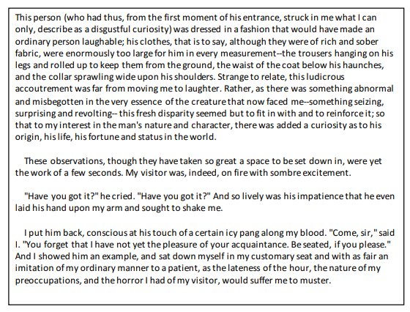
Starting with this extract, write about how Stevenson explores the idea of evil through Mr Hyde
Wednesday 19th March |  | An Inspector Calls
You should choose one question to plan an answer.

- Explore how Priestley creates sympathy for Eva Smith and women in her position in An Inspector Calls.

or

- Explore how Priestley presents the relationships between members of the Birling family in An Inspector Calls.

Thursday 20th March | Power and Conflict Poetry
Compare how poets present the power of relationships in ‘Poppies’ and one other poem.

Poppies – Jane Weir

Three days before Armistice Sunday
and poppies had already been placed
slowly melting. I was brave, as I walked
with you, to the front door, threw
it open, the world overflowing
like a treasure chest. A split second
and you were away, intoxicated.
After you'd gone I went into your bedroom,
released a song bird from its cage.
Later a single dove flew from the pear tree,
and this is where it has led me,
skirting the church yard walls, my stomach busy
making tucks, darts, pleats, hat-less, without
a winter coat or reinforcements of scarf, gloves.

On reaching the top of the hill I traced
the inscriptions on the war memorial,
leaned against it like a wishbone.
The dove pulled freely against the sky,
an ornamental stitch. I listened, hoping to hear
your playground voice catching on the wind.

on individual war graves. Before you left,
I pinned one onto your lapel, crimped petals,
spasms of paper red, disrupting a blockade
of yellow bias binding around your blazer.

Sellotape bandaged around my hand,
I rounded up as many white cat hairs
as I could, smoothed down your shirt's
upturned collar, steeled the softening
of my face. I wanted to graze my nose
across the tip of your nose, play at
being Eskimos like we did when
you were little. I resisted the impulse
to run my fingers through the gelled
blackthorns of your hair. All my words
flattened, rolled, turned into felt,

Optional extras | Language papers 1 and 2
LANGUAGE PAPER 1

At first, all seemed very quiet, very still, and I wondered why I had awoken. Then, with a missed heart-beat, I realized that Spider was up and standing at the door. Every hair of her body was on end, her ears were pricked, her tail erect, the whole of her tense, as if ready to spring. And she was emitting a soft, low growl from deep in her throat. I sat up paralysed, frozen, in the bed, conscious only of the dog and of the prickling of my own skin and of what suddenly seemed a different kind of silence, ominous and dreadful. And then, from somewhere within the depths of the house—but somewhere not very far from the room in which I was—I heard a noise. It was a faint noise, and, strain my ears as I might, I could not make out exactly what it was. It was a sound like a regular yet intermittent bump or rumble. Nothing else happened. There were no footsteps, no creaking floorboards, the air was absolutely still, the wind did not moan through the casement. Only the muffled noise went on and the dog continued to stand, bristling at the door, now putting her nose to the gap at the bottom and snuffling along, now taking a pace backwards, head cocked and, like me, listening, listening. And, every so often, she growled again.
In the end, I suppose because nothing else happened and because I did have the dog to take with me, I managed to get out of bed, though I was shaken and my heart beat uncomfortably fast within me. But it took some time for me to find sufficient reserves of courage to enable me to open the bedroom door and stand out in the dark corridor. The moment I did so, Spider shot ahead and I heard her padding about, sniffing intently at every closed door, still growling and grumbling down in her throat.
After a while, I heard the odd sound again. It seemed to be coming from along the passage to my left, at the very far end. But it was still quite impossible to identify. Very cautiously, listening, hardly breathing, I ventured a few steps in that direction. Spider went ahead of me, the passage led only to three other bedrooms on either side and, one by one, regaining my nerve as I went, I opened them and looked inside each one. Nothing, only heavy old furniture and empty unmade beds and, in the rooms at the back of the house, moonlight. Down below me on the ground floor of the house, silence, a seething, blanketing, almost tangible silence, and a musty darkness, thick as felt.
And then I reached the door at the very end of the passage. Spider was there before me and her body, as she sniffed beneath it, went rigid, her growling grew louder. I put my hand on her collar, stroked the rough, short hair, as much for my own reassurance as for hers. I could feel the tension in her limbs and body and it answered to my own.
This was the door without a keyhole, which I had been unable to open on my first visit to Eel Marsh House. I had no idea what was beyond it. Except the sound.

Q1: Use only the first paragraph. List four things you learn about the dog and its behaviour.
Q3: How has the writer structured the text to interest you as a reader?
LANGUAGE PAPER 2
Q3: How does the writer use language to convey their feelings about free school meals?

SOURCE A – 2024 – Sadiq Khan ‘As a child I needed free school meals, as mayor, I provide them.’
Hunger has a crippling influence on a child’s development. It robs them of their focus, energy and ambition. Hungry children in our classrooms are a source of national shame in a country as prosperous as ours. A growing number in London would have been unconscionable.
It is why, at the height of the cost of living crisis, and for the first time ever in our city, I took the decision to fund universal free primary school meals from City Hall. Now in its second year, the policy means that every pupil, in every state primary on every school day, can share a hot, healthy lunch with their classmates. In the first year of the scheme, more than 43m meals were served, benefiting up to 287,000 children. An independent report published this week confirms that our universal free school meals programme is proving a universal success for children, families, staff and schools – including in ways we did not anticipate.
Principally, the policy was introduced as a cost of living measure, and it has succeeded by helping parents and carers to save more than £1,000 per child since its inception. Yesterday’s report shows that 84% of families reported free school meals improved household finances. In many cases children were attending after-school clubs and trips, having previously been financially excluded.
The research also highlights an improvement in the health and wellbeing of children. Pupils enjoy school more and can concentrate for longer. Schools reported that classrooms are calmer and more productive. Children even tried new food – a triumph for every parent to celebrate. And by reducing financial stress on parents and carers, their mental wellbeing was similarly enhanced. Across the board, we see that those struggling the most are benefiting the most.

Q5: “All students should be entitled to free meals at school. If we value education, we will feed our children to make sure they’re able to learn and engage” – Write an article giving your viewpoint.
Monday 24th March | Macbeth
Read the following extract from act 5 scene 1. The doctor and gentlewoman watch Lady Macbeth.

Doctor
How came she by that light?
Gentlewoman
Why, it stood by her: she has light by her
continually; 'tis her command.
Doctor
You see, her eyes are open.
Gentlewoman
Ay, but their sense is shut.
Doctor
What is it she does now? Look, how she rubs her hands.
Gentlewoman
It is an accustomed action with her, to seem thus
washing her hands: I have known her continue in
this a quarter of an hour.
LADY MACBETH
Yet here's a spot.
Doctor
Hark! she speaks: I will set down what comes from
her, to satisfy my remembrance the more strongly.
LADY MACBETH
Out, damned spot! out, I say!--One: two: why,
then, 'tis time to do't.--Hell is murky!--Fie, my
lord, fie! a soldier, and afeard? What need we
fear who knows it, when none can call our power to
account?--Yet who would have thought the old man
to have had so much blood in him.

Starting with this extract, how does Shakespeare present the impact of memories in Macbeth?
Tuesday 25th March | Jekyll & Hyde
Read the following extract from chapter 9. In this extract Dr Lanyon is visited by Mr Hyde. Mr Hyde swallows the potion and transforms into Dr Jekyll in front of Lanyon.

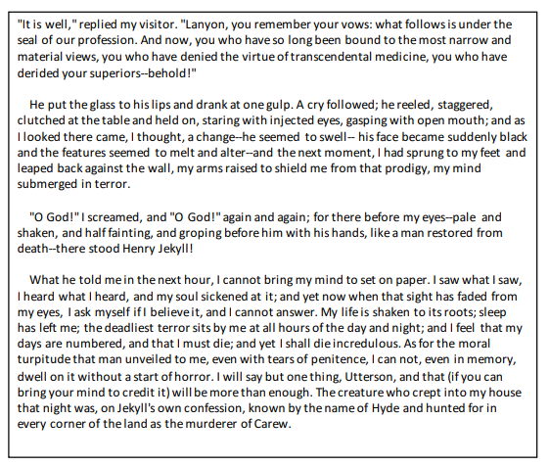
Starting with this extract, write about how Stevenson creates a sense of fear and horror in the novel.
Wednesday 26th March |  | An Inspector Calls
You should choose one question to plan an answer.

- Explore how Priestley presents the Inspector as a powerful character in An Inspector Calls.

or

- Explore how Priestley uses memories of Eva Smith to create guilt for the characters in An Inspector Calls.

Thursday 27th March | Poetry
Compare how poets present the impact of memory in ‘Remains’ and one other poem.

Remains – Simon Armitage

On another occasion, we got sent out
to tackle looters raiding a bank.
And one of them legs it up the road,
probably armed, possibly not.
End of story, except not really.
His blood-shadow stays on the street, and out on patrol
I walk right over it week after week.
Then I’m home on leave. But I blink

and he bursts again through the doors of the bank.
Sleep, and he’s probably armed, and possibly not.
Dream, and he’s torn apart by a dozen rounds.
And the drink and the drugs won’t flush him out –

he’s here in my head when I close my eyes,
dug in behind enemy lines,
not left for dead in some distant, sun-stunned, sand smothered land
or six-feet-under in desert sand,

but near to the knuckle, here and now,
his bloody life in my bloody hands.

Well myself and somebody else and somebody else
are all of the same mind,
so all three of us open fire.
Three of a kind all letting fly, and I swear

I see every round as it rips through his life –
I see broad daylight on the other side.
So we’ve hit this looter a dozen times
and he’s there on the ground, sort of inside out,

pain itself, the image of agony.
One of my mates goes by
and tosses his guts back into his body.
Then he’s carted off in the back of a lorry.

Optional extras | Language papers 1 and 2
LANGUAGE PAPER 1

Q2 How does writer use language to present the narrator’s feelings towards Calpurnia?

Calpurnia was something else again. She was all angles and bones; she was near-sighted; she squinted; her hand was wide as a bed slat and twice as hard. She was always ordering me out of the kitchen, asking me why I couldn’t behave as well 20.as Jem when she knew he was older, and calling me home when I wasn’t ready to come. Our battles were epic and one-sided. Calpurnia always won, mainly because Atticus always took her side. She had been with us ever since Jem was born, and I had felt her tyrannical presence as long as I could remember.
- To Kill a Mockingbird, Harper Lee

LANGUAGE PAPER 2

Q4: Compare the writers’ viewpoints on school attendance

SOURCE A – 2024 – Gillian Harvey ‘Labour is cracking down on truants, but as a mother and ex-teacher, I know tough love goes only so far’
When the education secretary, Bridget Phillipson, vowed last week to get “tough” on persistent school absenteeism, you might have expected someone like me – a former teacher, a mother of five and a firm believer in education – to applaud. There is plenty to welcome in Phillipson’s announcement: she has pledged to support parents and help children get back into the classroom. But when this approach doesn’t work, she is prepared to get “tough” – implying that the parents of persistently absent children need to be punished.
Some 21% of pupils in England are now labelled as “persistent absentees” – meaning they miss 10% or more of school time each year. Plenty of evidence suggests that these absences have a devastating impact on a pupil’s future: a report last year by the Children’s Commissioner for England revealed that only 36% of pupils who were persistently absent passed five or more GCSEs, compared with 78% of regular attenders. There are undoubtedly parents who need a little more stick and less carrot when it comes to ensuring their children are in school, and one approach has been to fine parents (currently, schools in England can issue a fine when children miss five days of school within a year for unauthorised reasons).
But to really tackle the problem we need to understand the myriad situations that lead to repeated absence in the first place. Years ago, when I was a teacher in the UK and not yet a parent, I couldn’t understand persistent absence, unless a child had a significant medical reason. As far as I was concerned, parents simply had to “make” their children attend school. Then in 2022, my eldest daughter developed school-focused anxiety. We cajoled her, reasoned with her and explained to her the importance of consistent attendance. But it got to the point where she simply felt she couldn’t go in.
Have you ever been faced with a near-teen who refuses to do something, despite all of your reasoned arguments and exasperated threats? I

SOURCE B – 1883, George R Sims, How The poor Live
The next to put in an appearance was a lady with a wretched-looking face and a shabby, draggled, out-all-night and drunk-in-the-morning appearance generally. Her profession was stated with official bluntness in the paper handed to the chairman. It is generally translated "street-walker" in family circles.
But, whatever she might be, she had children, and the law required them to come to school. Instead of making their attendances, learning to read and write, the children were street Arabs. The woman was meek and quiet enough. She promised "She'd see to it," and was reminded that she had
made the same promise before. This time it was not accepted, and the woman was informed that she would have to appear before a magistrate.
Meekly and quietly she said, "Thank you, sir," as if the chairman had presented her with a medal or a pound of tea, and went out.
The women poured in one after the other - there were very few men, most of them, I suppose, being "at work," whatever that term might imply in their particular case - and they were of all sizes, sorts, and conditions. There were respectable; decent, motherly-looking souls, drunken outcasts, half-starved and sickly-looking women, and fat, overwhelming women, who came not to be crushed, but to crush.
Monday 31st March | Macbeth
Read the following extract from act 3 scene 4. Macbeth is speaking to Lady Macbeth following the banquet where he saw Banquo’s ghost.

MACBETH
It will have blood; they say, blood will have blood:
Stones have been known to move and trees to speak;
Augurs and understood relations have
By magot-pies and choughs and rooks brought forth
The secret'st man of blood. What is the night?
LADY MACBETH
Almost at odds with morning, which is which.
MACBETH
How say'st thou, that Macduff denies his person
At our great bidding?
LADY MACBETH
Did you send to him, sir?
MACBETH
I hear it by the way; but I will send:
There's not a one of them but in his house
I keep a servant fee'd. I will to-morrow,
And betimes I will, to the weird sisters:
More shall they speak; for now I am bent to know,
By the worst means, the worst. For mine own good,
All causes shall give way: I am in blood
Stepp'd in so far that, should I wade no more,
Returning were as tedious as go o'er:
Strange things I have in head, that will to hand;
Which must be acted ere they may be scann'd.
LADY MACBETH
You lack the season of all natures, sleep.

Starting with this extract, how does Shakespeare present ideas about power in Macbeth?
Tuesday 1st April | A Christmas Carol
Read the following extract from chapter 9. In this extract Dr Lanyon is visited by Mr Hyde. Mr Hyde swallows the potion and transforms into Dr Jekyll in front of Lanyon.

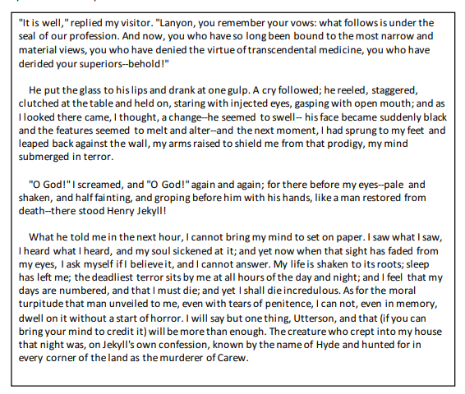
Starting with this extract, write about how Stevenson creates a sense of fear and horror in the novel.
Wednesday 2nd April |  | An Inspector Calls
You should choose one question to plan an answer.

- Explore how Priestley presents ideas about the younger generation in An Inspector Calls.

or

- Explore how Priestley presents ideas about abuse of power in An Inspector Calls.

Thursday 3rd April | Power and Conflict Poetry
Compare how poets present ideas about power in ‘Ozymandias’ and one other poem.

Ozymandias – Percy Bysshe Shelley

I met a traveller from an antique land
Who said: "Two vast and trunkless legs of stone
Stand in the desert. Near them, on the sand,
Half sunk, a shattered visage lies, whose frown,
And wrinkled lip, and sneer of cold command,
Tell that its sculptor well those passions read
Which yet survive, stamped on these lifeless things,
The hand that mocked them and the heart that fed:
And on the pedestal these words appear:
'My name is Ozymandias, king of kings:
Look on my works, ye Mighty, and despair!'
Nothing beside remains. Round the decay
Of that colossal wreck, boundless and bare
The lone and level sands stretch far away."

Optional extras | Language paper 1 and Language Paper 2
LANGUAGE PAPER 1
A mighty fist of wind socked the balloon in two rapid blows, one-two, the second more vicious than the first. It jerked Gadd right out of the basket on to the ground, and with Gadd's considerable weight removed from the equation, it lifted the balloon five feet or so, straight into the air. The rope ran through my grip, scorching my palms, but I managed to keep hold, with two feet of line spare. The others kept hold too. The basket was right above our heads now, and we stood with arms upraised like Sunday bell ringers. Into our amazed silence, before the shouting could resume, the second punch came and knocked the balloon up and westwards. Suddenly we were treading the air with all our weight in the grip of our fists. Those one or two ungrounded seconds occupy as much space in memory as might a long journey up an unchartered river. My first impulse was to hang on in order to keep the balloon weighted down. The child was incapable, and was about to be borne away. Two miles to the left were high-voltage power lines. A child alone and needing help. It was my duty to hang on, and I thought we would all do the same.
Almost simultaneous with the desire to stay on the rope and save the boy came other thoughts of selfpreservation and fear. We were rising, and the ground was dropping away as the balloon was pushed westwards. I knew I had to get my legs and feet locked round the rope. But the end of the line barely reached below my waist and my grip was slipping. My legs flailed in the empty air. Every fraction of a second that passed increased the drop, and the point must come when to let go would be impossible or fatal. Then, someone did let go. Immediately, the balloon and its hangers on lurched upwards another several feet.
Because letting go was in our nature too. Selfishness is also written on our hearts. Mostly, we are good when it makes sense. A good society is one that makes sense of being good. Suddenly, hanging there below the basket, we were a bad society, we were disintegrating. Suddenly the sensible choice was to look out for yourself. The child was not my child, and I was not going to die for it. Then I glimpsed another body fall away and I felt the balloon lurch upwards. The matter was settled. Altruism had no place. Being good made no sense. I let go and fell, I reckon, about twelve feet. I landed heavily on my side, I got away with a bruised thigh. Around me – before or after, I'm not so sure - bodies were thumping to the ground.
By the time I got to my feet the balloon was fifty yards away, and one man was still dangling by his rope. When I stood up and saw him, he was one hundred feet, and rising, just where the ground itself was falling. He wasn’t struggling, he wasn’t kicking or trying to claw his way up. He hung perfectly still along the line of his rope, all his energies concentrated in his weakening grip. He was already a tiny figure almost black against the sky and as the balloon and its basket lifted away and westwards, the smaller he became and the more terrible it was.
Our silence was a kind of acceptance, a death warrant. Or it was horrified shame. He had been on the rope so long that I began to think he might stay there until the balloon drifted down. But even as I had that hope we saw him slip down right to the end of the rope. And still he hung there. For two seconds, three, four. And then he let go and ruthless gravity played its part. And from somewhere a thin squawk cut through the stilled air. He fell as he had hung, a stiff little black stick. I've never seen such a terrible thing as that falling man.

Q3 How has the writer structured the text to interest you as a reader?
Q4 “The writer creates a vivid picture of this horrifying experience. You feel sympathy for all the characters” – To what extent do you agree?
LANGUAGE PAPER 2

Q5A “The most important subject is physical education. Without being fit and healthy no other learning matters. Secondary schools should run compulsory PE sessions every day.”
Write a speech to your teachers giving your views on this statement.

Q5B “Young people should be responsible for the environment. They are the ones who will live on this earth so they should be the ones to protect it.”
Write a blog for teenagers offering your views on the environment.

Monday 7th April | Macbeth
Read the following extract from act 4 scene 1. Macbeth has just been given his second set of prophecies.

MACBETH
Saw you the weird sisters?
LENNOX
No, my lord.
MACBETH
Came they not by you?
LENNOX
No, indeed, my lord.
MACBETH
Infected be the air whereon they ride;
And damn'd all those that trust them! I did hear
The galloping of horse: who was't came by?
LENNOX
'Tis two or three, my lord, that bring you word
Macduff is fled to England.
MACBETH
Fled to England!
LENNOX
Ay, my good lord.
MACBETH
Time, thou anticipatest my dread exploits:
The flighty purpose never is o'ertook
Unless the deed go with it; from this moment
The very firstlings of my heart shall be
The firstlings of my hand. And even now,
To crown my thoughts with acts, be it thought and done:
The castle of Macduff I will surprise;
Seize upon Fife; give to the edge o' the sword
His wife, his babes, and all unfortunate souls
That trace him in his line. No boasting like a fool;
This deed I'll do before this purpose cool.

Starting with this extract, how does Shakespeare present Macbeth inner conflict in Macbeth?
Tuesday 8th April | Jekyll & Hyde
Read the following extract from chapter 10. In this extract Dr Jekyll writes a statement to explain what he was like as a younger man.

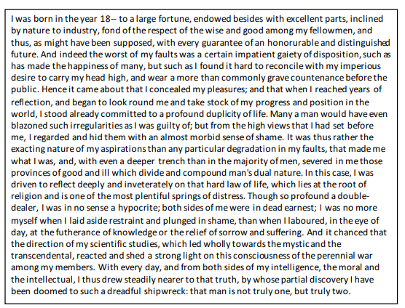
Starting with this extract, how does Stevenson present Dr Jekyll as a conflicted character?
Wednesday 9th April |  | An Inspector Calls
You should choose one question to plan an answer.

- Explore how Priestley presents the conflict between the lower and upper classes An Inspector Calls.

or

- Explore how Priestley presents the inspector’s conflict with the family members in An Inspector Calls.

Thursday 10th April | Power and Conflict Poetry
Compare how poets present ideas about conflict in ‘Kamikaze’ and one other poem.

Kamikaze – Beatrice Garland

Her father embarked at sunrise
with a flask of water, a samurai sword
in the cockpit, a shaven head
full of powerful incantations
and enough fuel for a one-way
journey into history
– yes, grandfather’s boat – safe
to the shore, salt-sodden, awash
with cloud-marked mackerel,
black crabs, feathery prawns,
the loose silver of whitebait and once
a tuna, the dark prince, muscular, dangerous.

And though he came back
my mother never spoke again
in his presence, nor did she meet his eyes
and the neighbours too, they treated him
as though he no longer existed,
only we children still chattered and laughed

till gradually we too learned
to be silent, to live as though
he had never returned, that this
was no longer the father we loved.
And sometimes, she said, he must have wondered
which had been the better way to die.

but half way there, she thought,
recounting it later to her children,
he must have looked far down
at the little fishing boats
strung out like bunting
on a green-blue translucent sea

and beneath them, arcing in swathes
like a huge flag waved first one way
then the other in a figure of eight,
the dark shoals of fishes
flashing silver as their bellies
swivelled towards the sun

and remembered how he
and his brothers waiting on the shore
built cairns of pearl-grey pebbles
to see whose withstood longest
the turbulent inrush of breakers
bringing their father’s boat safe

Optional extras | Unseen poetry and language paper 1
UNSEEN POETRY

How does the poet present the speaker’s ideas and attitude towards class and wealth?

The Class Game by Mary Casey
How can you tell what class I’m from?
I can talk posh like some
With an ’Olly in me mouth
Down me nose, wear an ’at not a scarf
With me second-hand clothes.
So why do you always wince when you hear
Me say ‘Tara’ to me ‘Ma’ instead of ‘Bye Mummy dear’?
How can you tell what class I’m from?
’Cos we live in a corpy*, not like some
In a pretty little semi, out Wirral way
And commute into Liverpool by train each day?
Or did I drop my unemployment card
Sitting on your patio (We have a yard)?
How can you tell what class I’m from?
Have I a label on me head, and another on me bum?
Or is it because my hands are stained with toil?
Instead of soft lily-white with perfume and oil?
Don’t I crook me little ­finger when I drink me tea
Say toilet instead of bog when I want to pee?
Why do you care what class I’m from?
Does it stick in your gullet like a sour plum?
Well, mate! A cleaner is me mother
A docker is me brother
Bread pudding is wet nelly
And me stomach is me belly
And I’m proud of the class that I come from.

*corpy: Liverpool slang for a council house
LANGUAGE PAPER 1
Q5: Write a description as suggested by the picture or write the opening of a story about a trip.

Monday 28th April | Macbeth
Read the following extract from act 2 scene 2. Macbeth has just returned from killing Duncan.

MACBETH
But wherefore could not I pronounce 'Amen'?
I had most need of blessing, and 'Amen'
Stuck in my throat.
LADY MACBETH
These deeds must not be thought
After these ways; so, it will make us mad.
MACBETH
Methought I heard a voice cry 'Sleep no more!
Macbeth does murder sleep', the innocent sleep,
Sleep that knits up the ravell'd sleeve of care,
The death of each day's life, sore labour's bath,
Balm of hurt minds, great nature's second course,
Chief nourisher in life's feast,--
LADY MACBETH
What do you mean?
MACBETH
Still it cried 'Sleep no more!' to all the house:
'Glamis hath murder'd sleep, and therefore Cawdor
Shall sleep no more; Macbeth shall sleep no more.'
LADY MACBETH
Who was it that thus cried? Why, worthy thane,
You do unbend your noble strength, to think
So brainsickly of things. Go get some water,
And wash this filthy witness from your hand.
Why did you bring these daggers from the place?
They must lie there: go carry them; and smear
The sleepy grooms with blood.
MACBETH
I'll go no more:
I am afraid to think what I have done;
Look on't again I dare not.

Starting with this extract, how does Shakespeare present ideas about good and evil in Macbeth?
Tuesday 29th April | Jekyll & Hyde
Read the following extract from chapter 10. In this extract Dr Jekyll writes a statement to explain what he was like as a younger man.

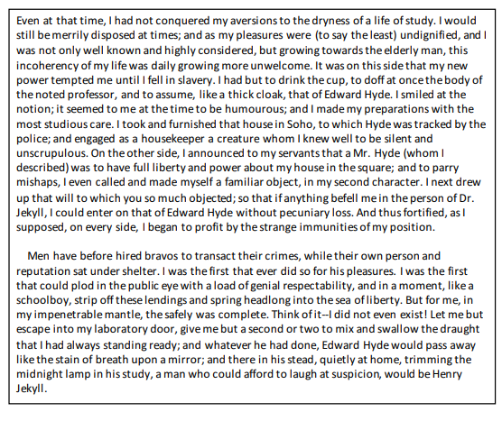

Starting with this extract, write about how Stevenson explores the idea of duality.
Wednesday 30th April |  | An Inspector Calls
You should choose one question to plan an answer.

- Explore how Priestley presents ideas about morality in An Inspector Calls.

Or

- Explore how Priestley presents the impact of the choices we make in An Inspector Calls.

Thursday 1st May | Power and Conflict Poetry
Compare how poets present ideas about good and bad in ‘London’ and one other poem.

London – William Blake

I wander through each chartered street
Near where the chartered Thames does flow,
And mark in every face I meet
Marks of weakness, marks of woe.

In every cry of every Man,
In every Infants cry of fear,
In every voice: in every ban,
The mind-forged manacles I hear:

How the Chimney-sweepers cry
Every black’ning Church appalls,
And the hapless Soldiers sigh
Runs in blood down Palace walls.

But most thro' midnight streets I hear
How the youthful Harlots curse
Blasts the new-born Infants tear,
And blights with plagues the Marriage hearse

Optional extras | Unseen poetry and language paper 2
LANGUAGE PAPER 1
There was music from my neighbor's house through the summer nights. In his blue gardens men and girls came and went like moths among the whisperings and the champagne and the stars. At high tide in the afternoon I watched his guests diving from the tower of his raft or taking the sun on the hot sand of his beach while his two motor-boats slit the waters of the Sound, drawing aquaplanes over cataracts of foam. On week-ends his RollsRoyce became an omnibus, bearing parties to and from the city, between nine in the morning and long past midnight, while his station wagon* scampered like a brisk yellow bug to meet all trains. And on Mondays eight servants including an extra gardener toiled all day with mops and scrubbing-brushes and hammers and gardenshears, repairing the ravages of the night before.
Every Friday five crates of oranges and lemons arrived from a fruiterer in New York—every Monday these same oranges and lemons left his back door in a pyramid of pulpless halves. There was a machine in the kitchen which could extract the juice of two hundred oranges in half an hour, if a little button was pressed two hundred times by a butler’s thumb.
At least once a fortnight a corps of caterers came down with several hundred feet of canvas and enough colored lights to make a Christmas tree of Gatsby’s enormous garden. On buffet tables, garnished with glistening horsd’oeuvre*, spiced baked hams crowded against salads of harlequin designs and pastry pigs and turkeys bewitched to a dark gold. In the main hall a bar with a real brass rail was set up, and stocked with gins and liquors and with cordials so long forgotten that most of his female guests were too young to know one from another.
By seven o’clock the orchestra has arrived—no thin five-piece affair but a whole pitful of oboes and trombones and saxophones and viols and cornets and piccolos and low and high drums. The last swimmers have come in from the beach now and are dressing upstairs; the cars from New York are parked five deep in the drive, and already the halls and salons and verandas are gaudy with primary colors and hair shorn in strange new ways and shawls beyond the dreams of Castile. The bar is in full swing and floating rounds of cocktails permeate the garden outside until the air is alive with chatter and laughter and casual innuendo and introductions forgotten on the spot and enthusiastic meetings between women who never knew each other’s names.
The lights grow brighter as the earth lurches away from the sun and now the orchestra is playing yellow cocktail music and the opera of voices pitches a key higher. Laughter is easier, minute by minute, spilled with prodigality*, tipped out at a cheerful word. The groups change more swiftly, swell with new arrivals, dissolve and form in the same breath—already there are wanderers, confident girls who weave here and there among the stouter and more stable, become for a sharp, joyous moment the center of a group and then excited with triumph glide on through the sea-change of faces and voices and color under the constantly changing light. - The opening of ‘The Great Gatsby’ F Scott Fitzgerald

Q2: How does the writer use language in the first paragraph to present the neighbour’s house?
Q3: How has the writer structured the text to interest the reader
Q4: “The writer makes the parties sound exciting and interesting. We want to learn more and this creates a mystery about the neighbour’s house” – To what extent do you agree with the statement
Q5: Write a description suggested by the picture or write a story where the narrator attends a party/festival.

Monday 5th May | Macbeth
Read the following extract from act 2 scene 1. Macbeth is preparing to kill King Duncan.

ROSS
The king hath happily received, Macbeth,
The news of thy success; and when he reads
Thy personal venture in the rebels' fight,
His wonders and his praises do contend
Which should be thine or his: silenced with that,
In viewing o'er the rest o' the selfsame day,
He finds thee in the stout Norweyan ranks,
Nothing afeard of what thyself didst make,
Strange images of death. As thick as hail
Came post with post; and every one did bear
Thy praises in his kingdom's great defence,
And pour'd them down before him.
ANGUS
We are sent
To give thee from our royal master thanks;
Only to herald thee into his sight,
Not pay thee.
ROSS
And, for an earnest of a greater honour,
He bade me, from him, call thee thane of Cawdor:
In which addition, hail, most worthy thane!
For it is thine.
BANQUO
What, can the devil speak true?
MACBETH
The thane of Cawdor lives: why do you dress me
In borrow'd robes?

“Macbeth starts the play as a good human but ends it as an evil human”
Starting with this extract, explore your views on this statement.
Tuesday 6th May | Jekyll & Hyde – Redo this question.
Read the following extract from chapter. In this extract Mr Enfield tells Mr Utterson about his meeting with Mr Hyde.
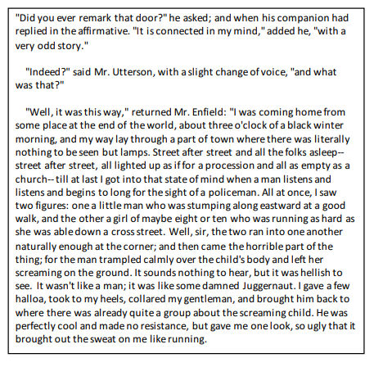
Starting with this extract, how does Stevenson present Mr Hyde as a frightening outsider?
Wednesday 7th May |  | An Inspector Calls
You should choose one question to plan an answer.

- Explore how Priestley presents ideas about the flaws of humanity in An Inspector Calls.

or

- Explore how Priestley offers a message to humanity in An Inspector Calls.

Thursday 8th May | Power and Conflict Poetry
Compare how poets present the strength of humanity in ‘Exposure’ and one other poem.

Exposure – Wilfred Owen

Our brains ache, in the merciless iced east winds that knife us...
Wearied we keep awake because the night is silent...
Sudden successive flights of bullets streak the silence.
Less deadly than the air that shudders black with snow,
With sidelong flowing flakes that flock, pause, and renew,
We watch them wandering up and down the wind's nonchalance,
But nothing happens.

Pale flakes with fingering stealth come feeling for our faces—
We cringe in holes, back on forgotten dreams, and stare, snow-dazed,
Deep into grassier ditches. So we drowse, sun-dozed,
Littered with blossoms trickling where the blackbird fusses.
—Is it that we are dying?

Slowly our ghosts drag home: glimpsing the sunk fires, glozed
With crusted dark-red jewels; crickets jingle there;
For hours the innocent mice rejoice: the house is theirs;
Shutters and doors, all closed: on us the doors are closed,—
We turn back to our dying.

Since we believe not otherwise can kind fires burn;
Now ever suns smile true on child, or field, or fruit.
For God's invincible spring our love is made afraid;
Therefore, not loath, we lie out here; therefore were born,
For love of God seems dying.
Low drooping flares confuse our memory of the salient...
Worried by silence, sentries whisper, curious, nervous,
But nothing happens.

Watching, we hear the mad gusts tugging on the wire.
Like twitching agonies of men among its brambles.
Northward incessantly, the flickering gunnery rumbles,
Far off, like a dull rumour of some other war.
What are we doing here?

The poignant misery of dawn begins to grow...
We only know war lasts, rain soaks, and clouds sag stormy.
Dawn massing in the east her melancholy army
Attacks once more in ranks on shivering ranks of gray,
But nothing happens.

Sudden successive flights of bullets streak the silence.
Less deadly than the air that shudders black with snow,
With sidelong flowing flakes that flock, pause and renew,
We watch them wandering up and down the wind's nonchalance,
But nothing happens.

Optional extras | Language paper 1 and Language paper 2
LANGUAGE PAPER 1

Q4:

Joseph knows the storm is coming. He sees the yellow glow of the halo around the moon and the ice-glitter of the winter sky when he comes up from the beach, pausing every now and then to give his knees rest from their groan and creak.
Later, the wind shifts, swinging from west to east and, waking in the night, he feels the beast of it crouched far out to sea, its arctic breath, its changed salt-smell. He could have warned the villagers who’d forgotten how to read the signs – the low flight of the gulls, the night sky, the wind – but why should he? Let the storm take their chimneys, fright their dogs, send shirts and sheets flying like winged banshees over rooftops. After all, what had anyone done, all those years before, when the storm had taken so much more from him?
A squall has picked up now over the Tops where cattle huddle in the barn and sheep lean together in the field. It rushes between the houses and the shops of Copse Cross Street and past the open window above the Grocer’s where Mrs Brown, still awake, peers down the narrow street and beyond to the black sheet of the starlit sea. She smells change on the wind and, securing the shutters, returns to her stove, scoops the dog, Rab, into her lap and waits.
Further down the hill, in a cottage near the Steps leading down to Skerry Sands, Dorothy lights a lamp and places it on the ledge of an upstairs window, a light in the darkness to guide home those lost in the heave and surge of the sea.
When the storm lands, there are things it steals from the little fishing village clinging to the cliffs. It takes roof tiles and sheep; it fells trees and splinters two boats against the Rocks. But it brings something too, something which Joseph will find when he goes back to check on his own boat in the watery light of the next day’s dawn.
A gift.

How does the poet present the speaker’s attitude towards her relationship and mobile phones?
LANGUAGE PAPER 2
Q3: How does the writer use language to convey their feelings about mobile phones.

SOURCE A – 2024 – Will Klempner ‘Hunched over my smartphone while my family slept, I knew I had to break my addiction. But how?’
I can’t pinpoint the exact moment I became addicted to my phone. It happens without you noticing, like a frog slowly boiling in a pot. I always told myself my excessive screen time wasn’t a big deal, that my life was better with my phone in it. I made every excuse in the book: I was learning new things, keeping my finger on the pulse, being an efficient employee and staying up to date with the people I love.
But in reality, none of that was true. My phone was such a powerful drug precisely because it gave me the illusion that it held infinite possibilities. But my experience of time and culture had slowly become flattened into two-dimensional memes and philosophical quotes, and I would bypass anything real – messages unanswered, calls unreturned – in favour of getting the next hit of dopamine. I found myself numb, disconnected from the world around me and unable to concentrate on anything for longer than a few minutes.
At the peak of my addiction, I would sit in the bathroom for hours after my wife had gone to bed, mindlessly scrolling, until I’d look up and realise another evening had slipped away, and all I had to show for it was a stiff neck and a sore thumb. By this point, the screen had become an escape from feelings of self-hate, and I knew something had to change. So I turned to the only resource I thought could help me.
There’s a certain irony in thinking that the solution to a problem with phone addiction can be found on your phone. But that’s the insidiousness of the whole thing. I set time limits, sought out podcasts and resources on how to claim back my attention. I had my wife apply a password to any app that wasn’t deemed “essential”. But in every instance, I found a way round it. And without immediate access to social media, I found myself scrolling through anything I could get my thumb on: photos, notes – even the weather app.Continental flights bad been cancelled by evening.

