
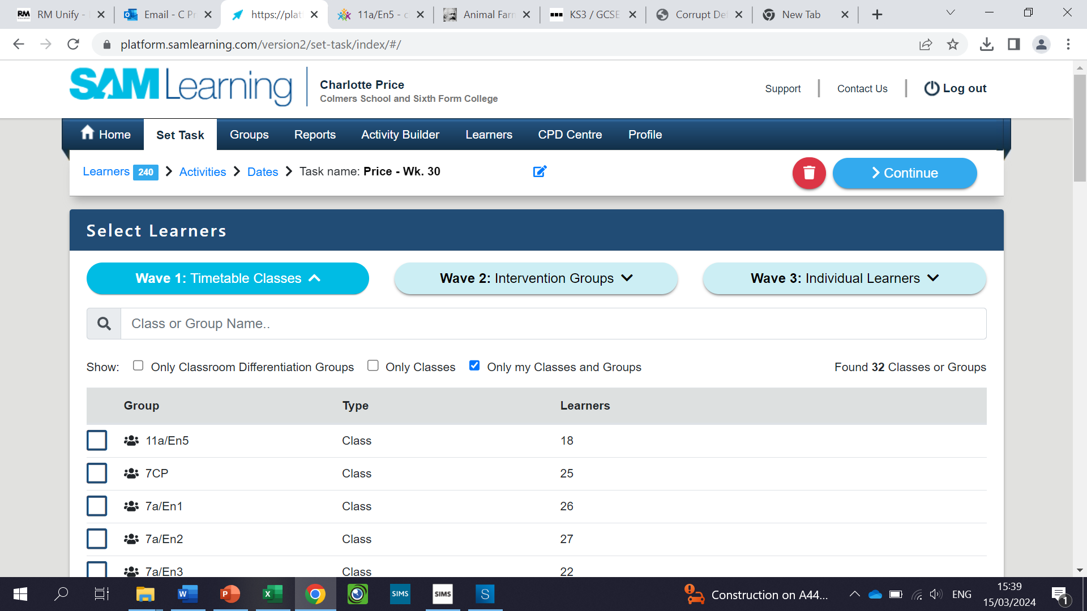
As well as the six tasks that you have in your booklet, there are also additional tasks that you will need to complete on SAM Learning too. These tasks have been chosen to help develop your understanding and remind you of things that you might have missed or forgotten from your lessons.
Each of the tasks have set deadlines. The links are available to you on Class Charts. You will only be set two tasks each week. You cannot access future tasks until the dates shown below.
Monday 4th November – Monday 11th November
- Macbeth and Jekyll and Hyde Revision
https://platform.samlearning.com/learner/learner-home/homework
Link to SAM Learning (also available on Class Charts):
Monday 11th November – Monday 18th November
- Macbeth and Jekyll and Hyde Revision
https://platform.samlearning.com/learner/learner-home/homework
Link to SAM Learning (also available on Class Charts):

Monday 18th November – Monday 25th November
- Macbeth and Jekyll and Hyde Revision
Link to SAM Learning (also available on Class charts)

https://platform.samlearning.com/learner/learner-home/homework

