Opening Minds, Opening doors

Colmers School and Sixth Form College


SPANISH
Key Stage 4

Year 11

11 Autumn examinations
Preparation Booklet
Monday 21st October 2024 – Friday 17th November 2024

NAME: _______________________________________________
FORM:________________________________________________
TEACHER:____________________________________________
Achieving Excellence, Belonging Together, Challenging Mindsets

Colmers School and Sixth Form College
Year 11 SPANISH preparation booklet
Autumn examinations

You have an assessment week during week beginning Monday 18th November 2024.
- This booklet will help you revise and prepare thoroughly for your assessment.
- This revision booklet is compulsory homework and must be completed
- Work your way through the booklet.
- If you are still struggling, then make sure you ask your teacher for further support.
- The first part of the booklet requires you to RAG rate the skills that you will need to demonstrate in your assessment.
- When completing tasks please ensure you complete it in a quiet environment. Try without any support first of all and then use your Knowledge Organiser to improve your answers.
- In your assessment you will not be able to use your book or your Knowledge Organiser. Use the  sections in this booklet if you get stuck
- Try your absolute best!

Tasks |  | Tick off which tasks you have completed. | Tasks
RAG Rate |  | Tick off which tasks you have completed. | Task 7
Task 1 |  | Tick off which tasks you have completed. | Task 8
Task 2 |  | Tick off which tasks you have completed. | Task 9
Task 3 |  | Tick off which tasks you have completed. | Task 10
Task 4 |  |  | Task 11
Task 5
Task 6 |  |  | Reflection
Week One  W/C 21st October | Week Two  W/C 04th November | Week Three  W/C 11th November
RAG Rate | Week 2  Tasks 4, 5, 6 and 7 | Week 3  Tasks 8,9, 10, 11
Week 1  Tasks 1,2,3 |  | Reflection


Colmers School and Sixth Form College
Year 11 Spanish preparation booklet
Autumn Examination

Your assessment will be assessing the following skills. Use this as a revision checklist.
Component taught | RAG Rating | Priority? How do you intend  to revise this?
Grammar Skills:  Use the future tense | R / A / G
Use the past tense | R / A / G
Use the present tense | R / A / G
Write on a range of topic accurately | R / A / G
Reading skills :
Read short passage to get key information | R / A / G
Read longer text to extract new vocabulary and key information | R / A / G
Listening skills
Listen short passage to get key information | R / A / G
Listen to longer text to extract key information | R / A / G

RAG rate the topics below – access vocabulary list from QR code to support you and revise key words independently.
Theme 1: Identity and culture
- Relationships with family and friends
- Marriage/partnership
- Social media
- Mobile technology
- Music
- Cinema and TV
- Food and eating out
- Sport
Theme 2: Local, national, international and global areas of interest
- Home, town, neighbourhood and region
- Charity/voluntary work
- Healthy/unhealthy living
- The environment
- Poverty/homelessness
- Travel and tourism
Theme 3: Current and future study and employment
- My studies
- Life at school/college
- Education post-16
- Jobs, career choices and ambitions
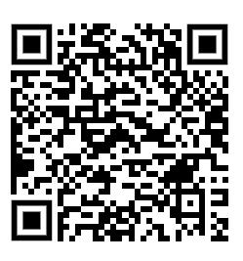
https://www.aqa.org.uk/subjects/spanish/gcse/spanish-8698/specification/subject-content/vocabulary
Use Sam Learning for reading task on targeted topics


TASK 1. Free time https://ds-resources.doublestruck.eu/AG_SPAN/MP3/Q181F07.mp3
WEEK 1
Some Spanish friends are talking about what they like to do in their free time and why they like the activity. For each person, write the correct letter of the activity and the number of the reason in the boxes.
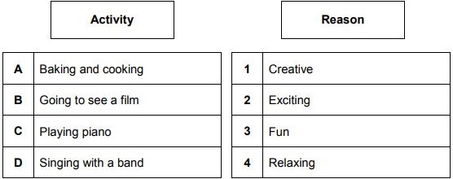
1 Pedro

(2)
2 Lorena
(2)
(Total 4 marks)
TASK 2 : Reading : Holidays - While on holiday Tazim updates his blog.
¡Hola! El pueblo de Chipiona es perfecto. Está en la costa y estoy aquí con mis padres y mi hermana Laila. Hace sol todos los días. Nuestro apartamento está a solo cinco minutos de la playa.

Write the correct letter in each box.
1 What is the weather like?
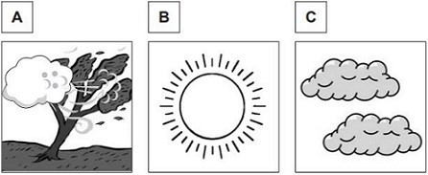

(1)
2 What type of accommodation is Tazim staying in?
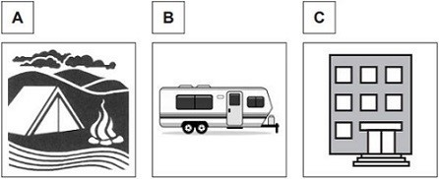

(1)

Por la mañana me baño. Luego juego al baloncesto con amigos españoles. Después de comer veo un programa en la tele. Mañana voy a visitar el pueblo a pie.
3 What does he do with his Spanish friends?
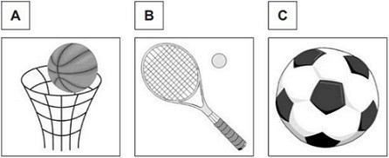

(1)
4 How will he visit the town tomorrow?
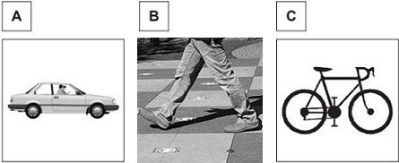

(1)
(Total 4 marks)

TASK 3. Translate into Spanish.

When it is cold, I play tennis with my friends.

I like to eat potatoes because it is delicious.

I am going to watch a fantasy movie this weekend.

Last weekend, I visited Madrid, it was excellent.

We can study English and drama, it is fun.

TASK 4 : Cristina’s home life in Spain
WEEK 2
https://ds-resources.doublestruck.eu/AG_SPAN/MP3/Q14SIG1F09.mp3
Write the correct letter in each box.
1 Where does Cristina live?

A | In a flat in the city centre
B | In a house on the outskirts of town
C | In a flat on the coast
(1)
2 What is Cristina’s favourite room?

A | Living room
B | Kitchen
C | Bedroom
(1)
(Total 2 marks)

TASK 5 : Complete a mind map with vocabulary related to where people live. Make lists of words on houses, landscape, rooms in the house, shops…

Types of houses:

Where I live

TASK 6 Opinions about home and local area
How do these people describe their feelings towards the place where they live?

Write | P | (Positive)
 | N | (Negative)
 | P + N | (Positive and Negative)

1 |  | Mi casa está en las afueras del pueblo. Por eso el barrio es tranquilo y me encanta. El inconveniente es el transporte público. No es nada barato.  Carlos
(1)

2 |  | Tengo mi propio dormitorio y cuarto de baño, por eso no tengo que usar el cuarto de baño de mis padres. Como me compré un televisor puedo ver lo que quiero y nadie me molesta.  Patricia
(1)

3 |  | ¿Qué es lo bueno de mi pueblo? Pues nada. Me gustaría vivir en un pueblo con más instalaciones interesantes para los jóvenes.  Marisol
(1)

4 |  | Vivo en la décima planta de un bloque de pisos con unas vistas preciosas. Últimamente no funciona el ascensor y estoy harto de subir las escaleras.  Raúl
(1)
(Total 4 marks)

TASK 7 – You write an email to a Spanish friend. Write a 40-word paragraph in Spanish about your health. Make sure you include the following aspects:
- Dieta
- Actividad física
- cigarillos
- alcohol

Check:
- Answers to all 4 bullet points
- Present tense is accurate – verbs end in O when using YO.
- Used 2 opinions justified with “porque”
- I avoided repetitions
- I added some adjectives, adverbs or time phrases
- I have linked my sentences with connectives.

TASK 8. El instituto de Jaime
WEEK 3
https://ds-resources.doublestruck.eu/AG_SPAN/MP3/Q10LF12.mp3
¿Cuál es la opinión de los amigos sobre su instituto?
Escribe | P  N  P + N | (Positiva)  (Negativa)  (Positiva y negativa)

1 | Laura
(1)
2 | Teresa
(1)
3 | Pablo
(1)
4 | Jaime
(1)
(Total 4 marks)

TASK 9. Hobbies
What do these people say they do in their free time?
A | I go fishing.
B | I go running.
C | I play basketball.
D | I play volleyball.
E | I play the drums.
F | I play the piano.

Write the correct letter in each box.

- Los domingos me encanta pescar con mis amigos en el río. (1)

- Cada martes toco la batería en mi habitación. (1)

- Corro en el parque después de hacer mis deberes. (1)

- Después de mis clases, juego al baloncesto con mi equipo. (1)

(Total 4 marks)
TASK 10. Pocket money
You see an online survey about how young people spend their money.

Example: | Revistas y libros | 37%
1 | Música y conciertos | 42%
2 | Comida y bebidas | 31%
3 | Transporte y vacaciones | 20%
4 | Ropa y zapatos | 39%
Complete the sentences.
Example:
37% spend their money on ...
magazines and books
1 42% spend their money on …
(1)

2 31% spend their money on …

(1)
3 20% spend their money on …

(1)
4 39% spend their money on …

(1)
(Total 4 marks)

TASK 11 - You discuss your region with a Peruvian woman. Write a 90-word paragraph in Spanish about where you live. Make sure you include the following aspects:
Menciona:
• un día interesante que pasaste con amigos recientemente
• tu opinión sobre tu casa
• un aspecto de tu región que no te gusta mucho
• dónde vas a vivir en el futuro.
Escribe aproximadamente 90 palabras en español. Responde a todos los aspectos de la pregunta.

Self check:
- Answers to all 4 bullet points
- Verbs in 3 tenses
- Opinions
- Connectives
- Adverbs and adjectives
- Description (where? When? How? Who with?)
- Originality (no repetitions – fancy structures and vocabulary

The skills that I feel that I have improved the most are:


Based on the RAG checklist, I can say that I am more confident with:


After completing this booklet, the activity that I found most helpful was:
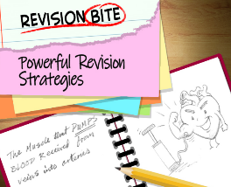

I would like more help with:


Teacher’s reflection:


Signed:
Colmers School and Sixth Form College
Year 11 Preparation Booklet
Autumn Examination

